The limit of a function is the behavior the output value approaches as the input value approaches a particular value. Limits are also examined when the output value keeps increasing or decreasing without bound. In this case the notation is $\lim_{x→∞}{( )}$, as is read as “the limit as the input value approaches infinity.” The limit exists when the function moves toward a single output value and fails to exist when it does not move toward one value. | 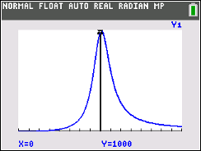

This activity has three parts. First, you will examine, graphically and numerically, the behavior of functions as the input approaches infinity. Next, you will examine graphically limits that do not exist because of continued chaotic output behavior as the input values continue to approach a particular value. Finally, you will examine a variety of limit problems.

Problem 1
Input this function into Y₁ in the Y = editor: $f\left(x\right)= \frac{2x^{2}+200x+1000}{x^{2}+1}$
(a) Record the function values for the inputs {1, 2, 3}. ____________________________

(b) Store the output values in a list as shown:
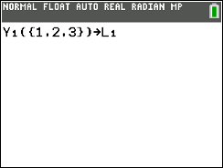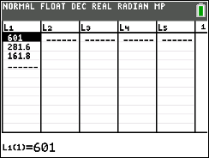

(c) Repeat the process for the input values {100, 200, 300}. Store the output values in L₂, and
record the values.
_____________________________

(d) Repeat the process for the input values {1000, 2000, 3000}. Store the output values in L₃, and
record the values.
_____________________________
(e) With a classmate, look at the values in all three sets and draw a conclusion regarding the
behavior of the function.

_______________________________________________________________________

_______________________________________________________________________

(f) To confirm your conclusion, try the input values {10¹⁰, 10¹⁵, 10²⁰}, and record your results.

_______________________________

(g) With a classmate, discuss if the function actually reaches the exact value of the limit. Share with
the class if you think this is a reasonable result.

______________________________________________________________________

______________________________________________________________________

(h) Now let’s look at the behavior graphically. Take several minutes exploring what viewing windows
you would need to see the behavior from the input values listed in parts a, c, d, and f. Compare
your windows on the handheld with a classmate and discuss what you notice.

(i) Estimate: $\lim_{x→∞}{\frac{{2x}^{2}+200x+1000}{x^{2}+1}}$ _______________________________

(j) With a classmate, investigate and draw a conclusion of the following limit:
$\lim_{x→-∞}{\frac{{2x}^{2}+200x+1000}{x^{2}+1}}$

______________________________________________________________________

______________________________________________________________________

Problem 2

Now investigate the limit $\lim_{x→∞}{{\left(1+ \frac{1}{x}\right)}^{x}}$ as you did in Problem 1. Fill in the following table given the
following input values:

X | L₁ | X | L₂ | X | L₃ | X | L₄
1 |  | 100 |  | 1000 |  | 10¹⁰
2 |  | 200 |  | 2000 |  | 10¹⁵
3 |  | 300 |  | 3000 |  | 10²⁰

(a) With a classmate, discuss what you notice as the input values approach infinity.

____________________________________________________________________

____________________________________________________________________

(b) Given the following viewing window, graph the function and use the trace button to help
describe what you see.
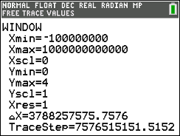

____________________________________________________________________

____________________________________________________________________

(c) State and explain the limit: $\lim_{x→∞}{{\left(1+ \frac{1}{x}\right)}^{x}}$

____________________________________________________________________

____________________________________________________________________

Problem 3

Before you practice limits on your own, let’s examine the behavior of one more function: $f\left(x\right)=\sin\left(\frac{1}{x}\right)$
Use the following window, make sure your handheld is in radian measure and graph $f(x)$. Please set your Zoom Factors by pressing zoom, memory, 4: SetFactors. Make sure XFact = 4 and YFact = 1.

Discuss with a classmate what you notice about the function as the input values approach 0 and describe your results of the limit: $\lim_{x→∞}{\sin\left(\frac{1}{x}\right)}$

__________________________________________________________________________________

__________________________________________________________________________________

Practicing Limits

Evaluate the limit for each expression:

1. $\lim_{x→0}{\frac{\sin{(x)}}{x}}$ ____________________

2. $\lim_{x→∞}{\frac{x-2}{2x+5}}$ ____________________

3. $\lim_{x→0}{\frac{\left|x\right|}{x}}$ ____________________

4. $\lim_{x→0}{\frac{\sin{(5x)}}{4x}}$ ____________________

5. $\lim_{x→-∞}{\frac{4x-1}{\sqrt{x^{2}+2}}}$ ____________________

6. $\lim_{x→1}{\frac{x^{3}-1}{x-1}}$ ____________________

7. $\lim_{x→2}\left(\frac{1}{x-2}- \frac{4}{x^{2}-4}\right)$ ____________________

Further IB Applications

1. (a) Sketch the graph $y= \frac{x^{2}-4}{x-2}, x ≠2$.

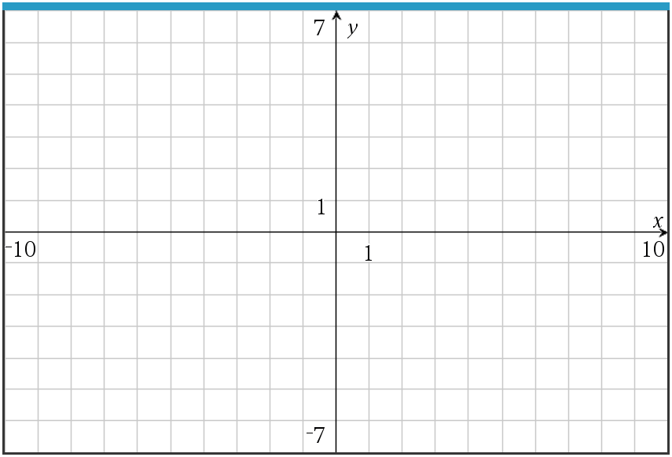

(b) Find $\lim_{x→2}{\frac{x^{2}-4}{x-2}}$ numerically. ____________________________________

2. (a) Consider the function $f\left(x\right)= \frac{3x}{x-2}, x≠2$. Sketch the function.

(b) Evaluate the limit: $\lim_{x→∞}{\frac{3x}{x-2}}$ _____________________________

